Lista step eseguiti per l’analisi della richiesta

- Import CSV file
- Executed a 1st purely visual analysis
- Checked if the Primary Key is valid -> yes it is
  - 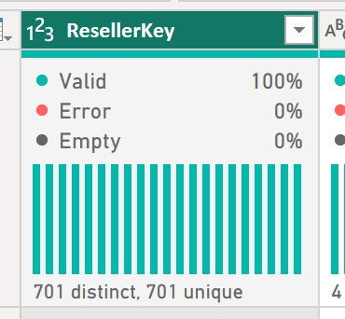
- Realized pretty much immediately that there are redundancy problems in this dataset
  - 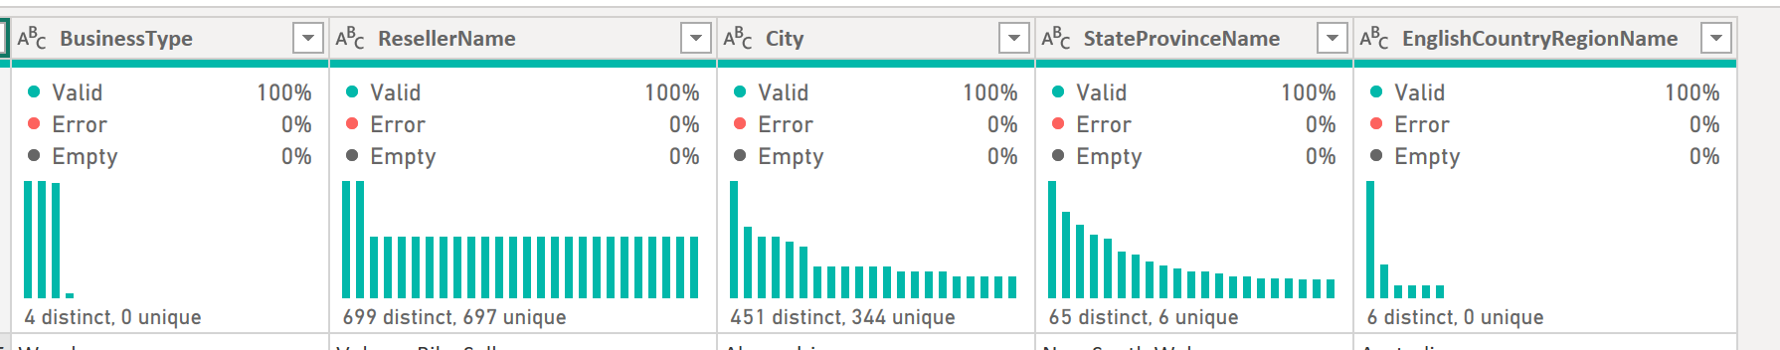
  - BusinessType has to be normalized, only 4 distinct values and none are uniques
  - ResellerName does not reflects PrimaryKey unicity, so we’ll drill down
  - City also needs to be normalized; also there could be typing errors so check that as well
  - StateProvinceName same as before
  - EnglishCountryRegionName same as before
- After that analysis, I’ve concluded that Reseller will be composed by ResellerKey and the related unique ResellerName, and we’ll think later on how to connect the infos
- 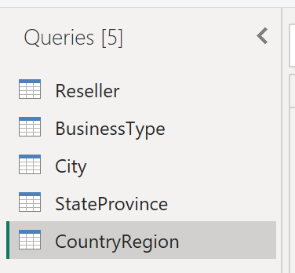
  - These are the normalized tables. I will now proceed to duplicate the main Reseller table, normalize that one too to make all Dimension tables, and create a Fact table that connects all the data model.
- 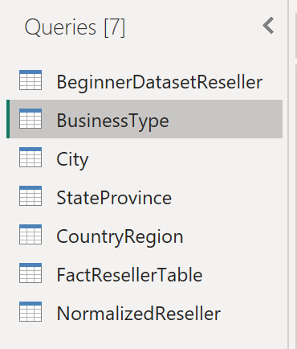
  - I’ve retained the original dataset only for academic purposes, but actually we have built 5 Dim tables and created a Fact table which is almost like the original, but only made by indexes.
- In the data model, I’ve built the relationships and retained the BeginnerDatasetReseller once again only for academic purposes. The real relationships are between the 5 Dim tables and the Fact table.
- 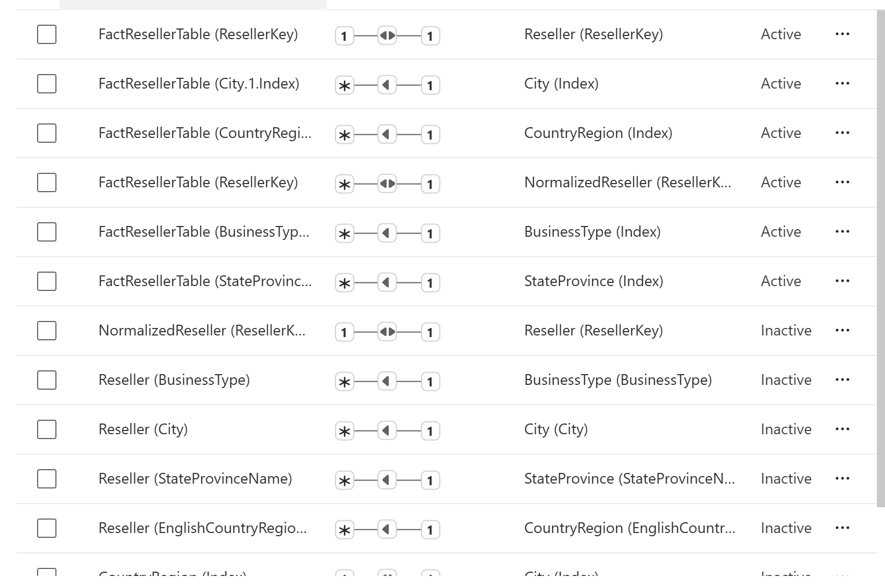
  - Here I’ve manually set which relationships are active and which are not
- Once done, I’ve built a standard table to check the results.

